Graphics OpenGL Assignment
Delivery:
- After you complete the whole assignment, submit one screenshot of the scene you drew and the final Renderer.cs file in the form.
- Type on your screenshot using an external image editor your full name in Arabic, ID, department and section, and rename it with your id )example: 2020170754.jpg(
- On the beginning of the Renderer.cs, type inside a comment your full name in English, ID, department, and section. And also, rename it with your id )example: 2020170754.cs(.
- Each student is allowed to submit ONLY one response containing the complete task, you are allowed to edit your submission.
- Submission deadline for all departments is: Friday, 27 March 2026 11:59 PM
- Submission Link: [link]
Delivery Example files:
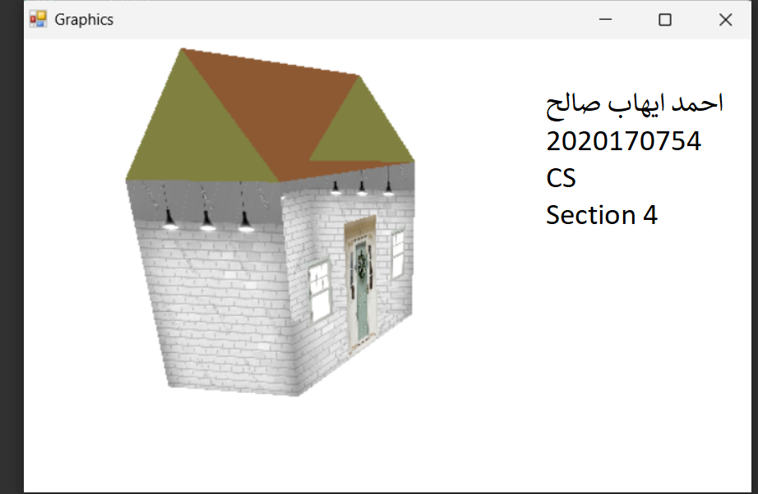
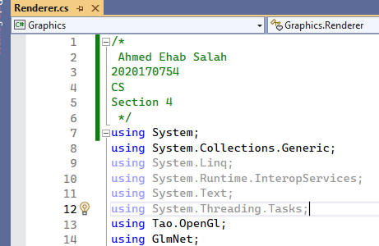

General Rules:
- The assignment is graded out of 10.
- You can use the complete code of lab 3 as the startup project.
- This is an individual task. Collaboration or group work is not permitted.
- Don’t ever share your scene/code with your colleagues!
- A plagiarism-checking algorithm will be applied. A detected cheating will get a ZERO

The assignment consists of three milestones over the coming three weeks:

Milestone 1: Draw a 3D object!
- Draw in 3D using OpenGL any simple Colored character/scene/shapes of your choice (ex: - cube, pyramid, chair, table…).
- Use different colors for different parts in your character/scene.
- Use at least 5 different primitives in your scene.
- There should be at least 1 quad (square, rectangle, …) in your drawing.
- Adjust the camera so it captures the drawn character/scene.

Milestone 2: Apply Transformations
- Transformations should be applied in both ways:
  - Using a keyboard.
  - Self-animated (without disappearing from the view).
- For example: - the drawn character may move left-right-up-down using the keyboard and simultaneously scale up-down itself.

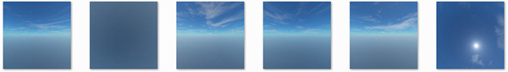
Milestone 3: Apply Textures
- Apply a texture on the drawn quad in your scene. so, part of your scene will be colored, and the other part will be textured.
- Use any image to be your texture.

